Plasmid information
plasmid | enzyme I | Bufffer | enzyme II | Bufffer | enzyme III | Bufffer
AKT1-PT3EF1αH  AKT2-PT3EF1αH  β-cat-PT3EF1αH  β-cat-S45Y-1αH  C-myc-PT3EF1αH  hMet-PT3EF1αH  Mmcl1-PT3EF1αH  NICD--PT3EF1αH | BamH1-HF | 4 | EcoRV | 3+BSA
sgAxin  sgPTEN | SacI | 1+BSA | SphI | 2
AKT-shraptor  dnTEAD2-PT3EF5α  PIK3 E545K PT3EF5α | BglII | 3 | EcoRI-HF | 4 | HindIII-HF | 4
TAZS89A-PT3EF5αH  AKT-shluc- PT3EF5α | BamH1-HF | 4 | EcoRI-HF | 4 | HindIII-HF | 4
PT3EF1αH | BglII/NotI | 3+BSA
PBS185 CMV Cre | Xbal | 4+BSA | EcoRV/PstI | 4+BSA
PBS-185 | BamH1-HF | 4 | Xbal | 4+BSA
Nras v12-caggs | EcoRI-HF | 4 | HindIII-HF | 4
PT2-shP53 | EcoRI-HF | 4 | KpnI | 1+BSA
PT3Gluc | EcoRI-HF | 4 | HindIII-HF | 4
YAPS127A-PT3EF1αH | BamH1-HF | 4 | EcoRV | 3+BSA
SB | SacI | 1+BSA

Note: All these plasmids are selected by Ampicillin; Growth temperature is 37°C and Growth strain is top10. The ladder is https://www.thermofisher.com/order/catalog/product/10787026.

1. AKT1-PT3EF1αH (https://www.addgene.org/31790/)
Digestive enzyme: BamH1; EcoRV
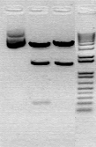
Digest map:
1 2 3
1 uncut
2 BamHI
3 EcoRV

2. TAZS89A-PT3EF5α
Digestive enzyme: BamH1-HF,EcoRI-HF,HindIII-HF
Digest map
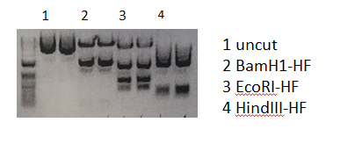
- Mmcl1-PT3EF1αH
Digestive enzyme: BamH1-HF,EcoRV
Digest map 1 2 3 1 2 3
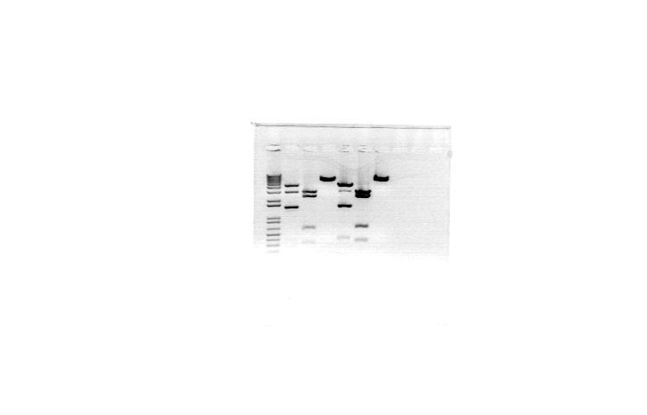
1 EcoRI
2 Hind 3
3 Bgl 2

4. SB
Digestive enzyme: sacI
Digest map 1 2 1 2 1 2
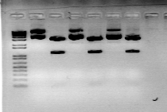
1 uncut
2 sacI

4 BglII

5. sgPTEN/PX330
Digestive enzyme: sacI,sphI
Digest map
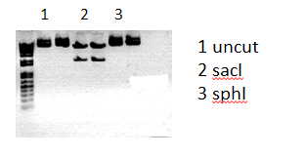
6. AKT-shraptor
Digestive enzyme: BglII,EcoRI-HF,HindIII-HF
Digest map
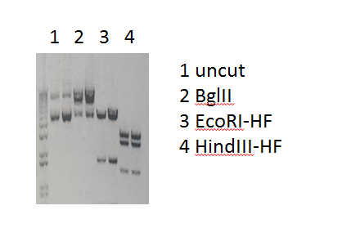

7. h-Met-PT3EF1 αH(https://www.addgene.org/86498/)
Digestive enzyme: BamH1-HF; EcoRV
Digest map
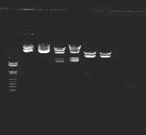
1 1 2 2 3 3
1 uncut
2 BamHI
3 EcoRV

8. PBS185
Vector: pBS185 (from pBS185 CMV-Cre)
Insert: Cre (delete 420bp by Bamh1 compare to pBS185 CMV-Cre)
Insert origin: (cloning ID: Plasmid #11916 , Addgene)
Insert size: 680bp
Digestive enzyme: BamH1-HF,Xbal
Digest map
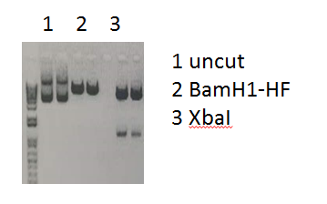

9. β-cat- PT3EF1 αH(https://www.addgene.org/86499/)
Digestive enzyme: BamH1-HF; EcoRV
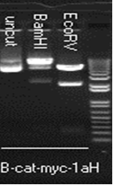
Digest map

10. Nras v12-caggs
Digestive enzyme: HindIII-HF; EcoRI-HF
Digest map
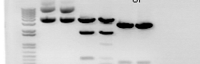
- 1 2 2 3 3
1 uncut
2 EcoR 1
3 Hind 3

4 BglII

11. PT2shP53
Digestive enzyme: EcoRI-HF,KpnI
Digest map:
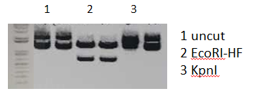
12. sgAxin/PX330

Digestive enzyme: SacI,SphI
Digest map:
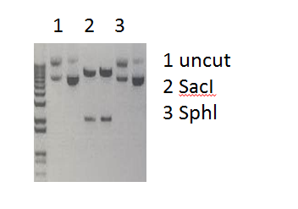
13. PT3EF1αH
Digestive enzyme: BglII/NotI
Digest map:
1 1 2 2
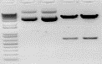
1 uncut
2 BglII/ NotI

4 BglII

14. β-cat-S45Y-PT3EF1αH
Digestive enzyme: BamH1-HF, EcoRV
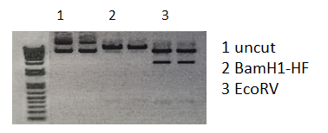
Digest map:

15. YAPS127A-PT3EF1αH (https://www.addgene.org/86497/)
Digestive enzyme: BamH1-HF, EcoRV
Digest map:
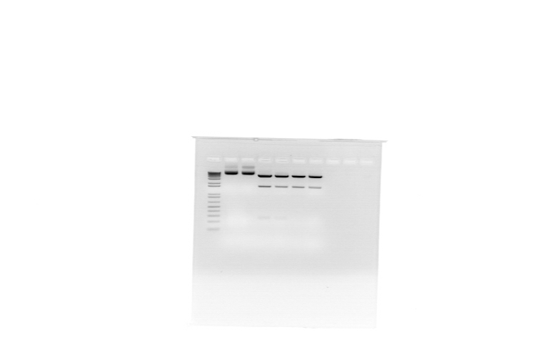
1 1 2 2 3 3
1 uncut
2 BamHI
3 EcoRV

16. PT3EF5 α dataF-PI3KCA-H1047R
Digestive enzyme: BglII,EcoRI-HF,HindIII-HF
Digest map:
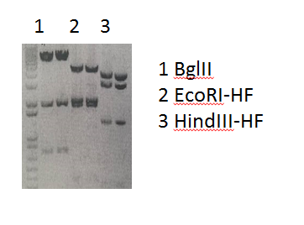
17. AKT-shluc-5αH
Digestive enzyme: BamH1-HF, EcoRI-HF, HindIII-HF
Digest map:
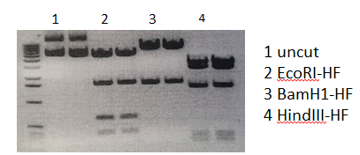
18.dnTEAD2-PT3EF5a
Digestive enzyme: BamH1-HF, EcoRI-HF, HindIII-HF
Digest map:
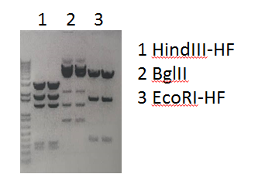
19. pBS185 CMV-Cre(Addgene https://www.addgene.org/11916/)
Digestive enzyme: Xbal, EcoRV/PstI
Digest map:
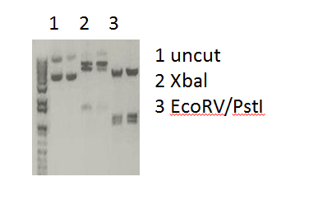
20. C-myc-PT3EF1αH(Addgene: #92046)
Digestive enzyme: BamH1-HF, EcoRV
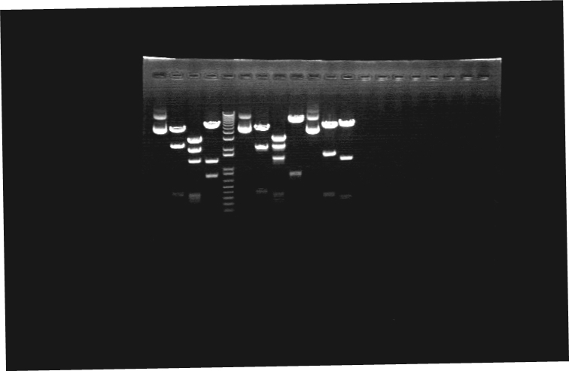
Digest map:
1 2 3
1 uncut
2 BamHI
3 EcoRV

21. PI3KE545K-PT3EF5α
Digestive enzyme: BglII, HindIII-HF, EcoRI-HF
Digest map:
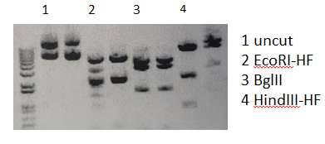
22. myr-AKT2-PT3EF1aH
Digestive enzyme: BamH1-HF, EcoRV
Digest map:
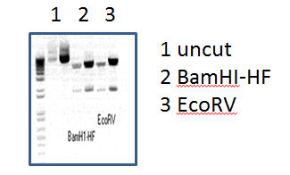
23. NICD-PT3EF1αH (https://www.addgene.org/46047/)
Digestive enzyme: BamH1-HF, EcoRV
Digest map:
1 2 3
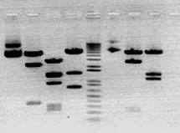
1 uncut
2 BamHI
3 EcoRV

